Team Name: The Outlanders



N/A. (n.d.). Hiking Clipart. Clipart Panda.

Retrieved July 9, 2022, from

<http://images.clipartpanda.com/hiking-clipart-hike.gif>

Team Members:

Chris Beatty - <https://github.com/AnotherByte/csd-310>.git

Brian Gossett - <https://github.com/BrianGossett/csd-310.git>

Larissa Passamani Lima - [https://github.com/passamani15/csd-310](https://github.com/passamani15/csd-310/tree/main/csd-310-1/).git

Christeen Safar - [https://github.com/ChristeenS/csd-310](https://github.com/ChristeenS/csd-310/tree/main/module_10).git

Michele Speidel - <https://github.com/jamdmmsfreese/csd-310>.git

Module 11.1 Assignment

Milestone #3

CSD310-330H_2225_DD

Database Development and Use

Date: July 17, 2022

# Case Study Selected

Outland Adventure

# Assumptions

-Owners are considered in the employee table

-Each destination has its own flat airline fee

-Only new equipment is purchased to sell or rent but the owners brought new equipment to the business which can be several years old

-Card number represents payment information customer would provide

-Every customer and employee on a trip is going on all excursions

-Items include equipment, supplies, and safety essentials

-Camping is part of the excursion activities

-If customer_order table shows “is_rental” field as “0”, customer decided to buy equipment

-Each excursion will be documented per day (If excursion takes multiple days, it will be listed once per day)

-Each of the Guides will be required to have each of the items required for the trip

-If a trip requires an item, only one person will be required to check out the item

-The project does not provide interactive website reports for customers to check trip schedules or purchase equipment. There is an interactive report to show equipment over X years old.

-All trips are assumed to be paid for so there is no invoice or billing information provided in this report.

-The business has expanded since this case study was written to conduct trips in North America and Northern Europe

-Customer inoculation records were updated while evaluating this case study. Customers provided additional information since the tables were originally created.

# List of Reports

1.Customer Buy

2.Customer Rent vs Buy

3.Region Total Trips

4.Region Total Customers

5.Trip Region Total Customer

6.Equipment Needed Per Trip

7.Customer Visa And Shot Records

8.Employee Visa And Shot Records

9.Trip Schedule

10-A.Item By Age

10-B.Item By Age Interactive

## 1.Customer Buy Report

## 2.Customer Rent vs Buy Report

### Purpose of Reports

These reports will help determine if enough customers buy enough equipment to keep equipment sales.

-The CEOs, Blythe and Jim, need these reports to analyze business optimization strategies regarding the sales of equipment.

### Report Description

These two reports show how the equipment sales are going. Report 1. displays the customer’s name, the item they purchased, is_rental is false (so it must be a purchase), and the date they purchased the item. Report 2. is a count of the items rented vs the items bought. Each time a customer orders an item, a record is created. This report compares the number of rental records against the number of purchase records. The result helps visualize the popularity of each option (rent vs buy).

#### 

#### 1.Customer Buy Report

SELECT C.first_name, C.last_name, IT.description, case when CO.is_rental = TRUE then 'Rent' else 'Buy' end AS 'Buy or Rent', CO.out_date

FROM item AS I

INNER JOIN item_type AS IT

ON I.item_type_id = IT.item_type_id

INNER JOIN customer_order AS CO

ON I.item_id = CO.item_id

INNER JOIN customer AS C

ON CO.customer_id = C.customer_id

WHERE CO.is_rental = false;

#### 

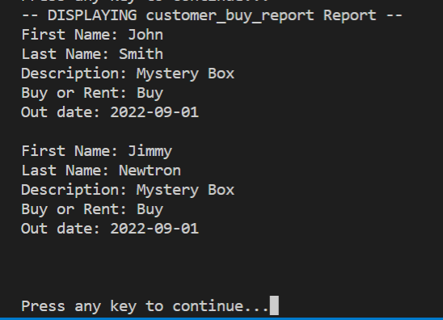

#### 2.Customer Rent vs Buy Report Report

SELECT case when CO.is_rental = TRUE then 'Rent' else 'Buy' end AS 'RentVsBuy' , COUNT(*)

FROM item AS I

INNER JOIN item_type AS IT

ON I.item_type_id = IT.item_type_id

INNER JOIN customer_order AS CO

ON I.item_id = CO.item_id

INNER JOIN customer AS C

ON CO.customer_id = C.customer_id

GROUP BY CO.is_rental

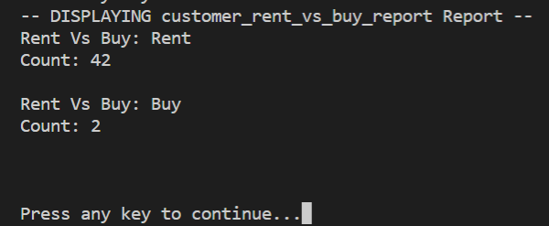

## 3.Region Total Trips Report

## 4.Region Total Customers

## 5.Trip Region Total Customer

### Purpose of Reports

These reports provide the total trips per region, the total customer count scheduled for each trip, and the customer count for each trip date to determine which destinations are popular vs unpopular.

-The CEOs, Blythe and Jim, need reports to show booking trends, specifically to determine if Africa, Asia, Southern Europe have downward trends in bookings

-Anita will need these reports to focus marketing efforts on certain regions based on business optimization goals

### Report Description

These three reports show how trip scheduling is going. Report 3. displays the number of trips planned per region. Report 4. Shows the number of customers scheduled for each trip region. Report 5. shows the date of each trip, which region is scheduled and how many customers are scheduled for each tip date. The results help determine how to optimize company resources, plan trips, and determine a concentrated marketing plan.

#### 3.Region Total Trips Report

List of destinations and how many trips to each destination (popular; not popular)

WHERE D.region='Africa' OR D.region='Asia' OR D.region='Southern Europe'

SELECT D.region AS 'Region', COUNT(T.trip_id) AS 'Total Trips'

FROM trip AS T

RIGHT JOIN destination AS D

ON T.destination_id = D.destination_id

GROUP by D.region

ORDER by D.region;

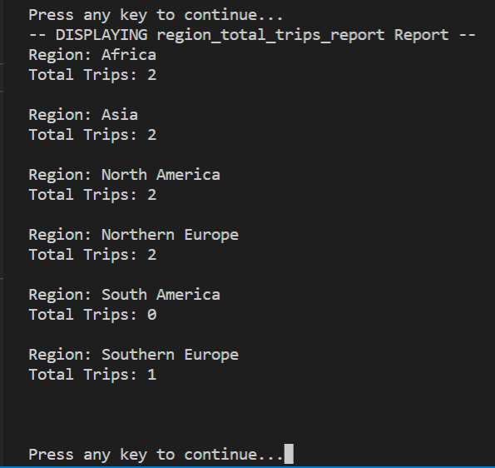

#### 4.Region Total Customers Report

SELECT D.region AS 'Region', COUNT(CT.customer_trip_id) AS 'Total Customer Trips'

FROM customer_trip AS CT

RIGHT JOIN trip AS T

ON CT.trip_id = T.trip_id

RIGHT JOIN destination AS D

ON T.destination_id = D.destination_id

GROUP by D.region

ORDER by D.region;

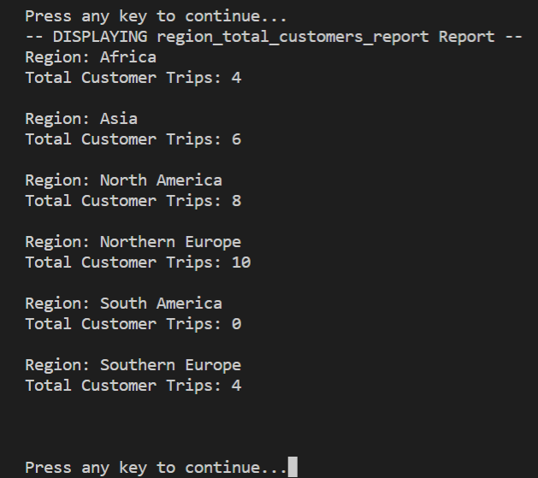

#### 5.Trip Region Total Customer Report

SELECT T.trip_id AS 'Trip Number', D.region AS 'Region', T.begin_date AS 'Trip date', COUNT(CT.customer_trip_id) AS 'Total Customer Trips'

FROM customer_trip AS CT

RIGHT JOIN trip AS T

ON CT.trip_id = T.trip_id

RIGHT JOIN destination AS D

ON T.destination_id = D.destination_id

GROUP by T.trip_id

ORDER by T.begin_date;

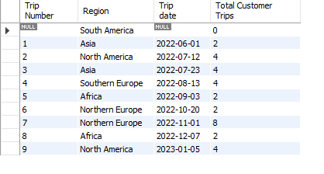

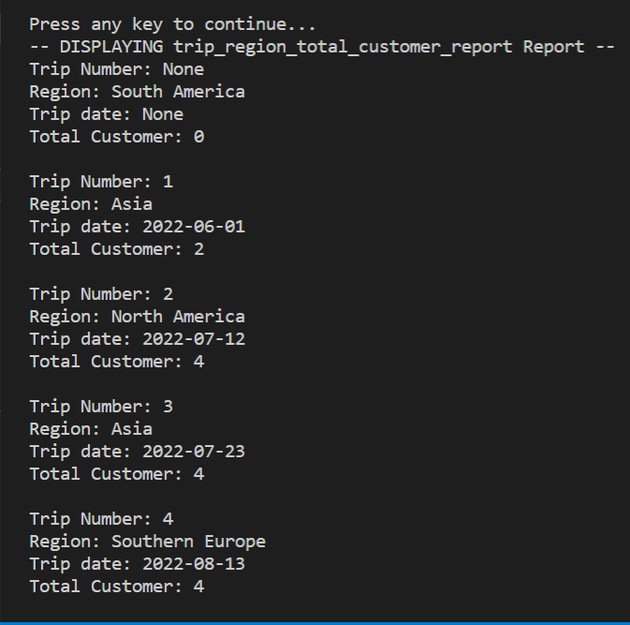

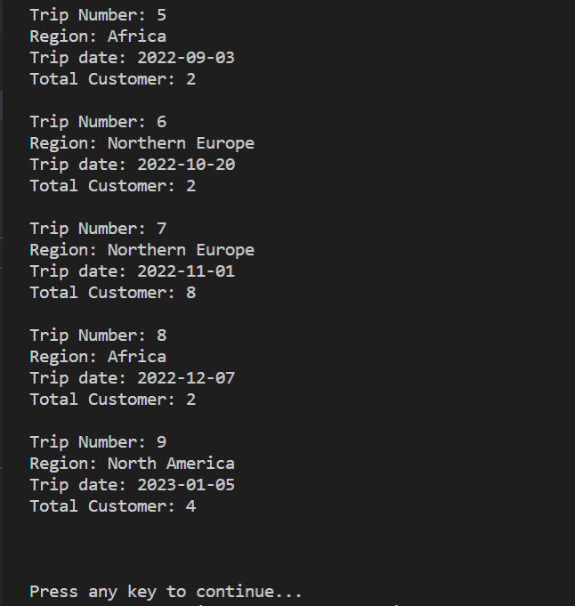

## 6.Equipment Needed Per Trip Report

### Purpose of Report

This report provides the equipment needed by region.

-Tour Guides and Customers will need to know what equipment is required per Trip so they can prepare to rent or sell.

-Dimitrios needs reports for trip inventory to identify what equipment is needed.

### Report Description

This report displays all of the required items for each of the trips. Each trip is listed for as many rows as items that are required on that trip. The trip_id and region name are displayed for each trip. The item description for each item needed is displayed rather than an item_type_id so it can be easily read. A “WHERE T.trip_id = ?” clause could be run on the view to limit the results to one trip.

#### 6.Equipment Needed Per Trip Report

--equipment needed per trip

SELECT T.trip_id, D.region, IT.description

FROM trip AS T

JOIN destination AS D

ON T.destination_id = D.destination_id

JOIN trip_item AS TI

ON T.trip_id = TI.trip_id

JOIN item_type AS IT

ON TI.item_type_id = IT.item_type_id

ORDER BY T.trip_id, IT.description;

#### 

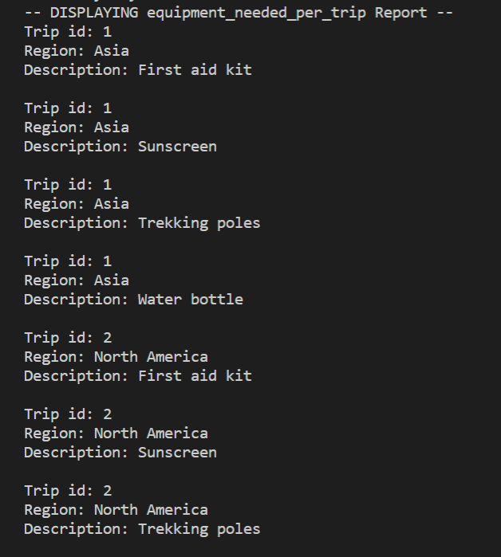

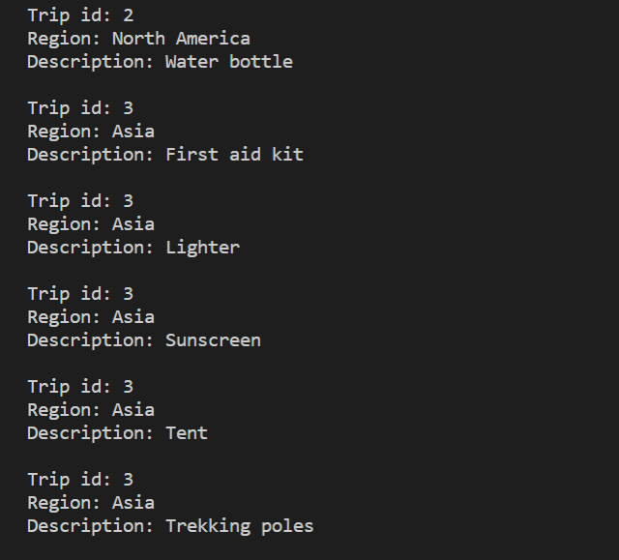

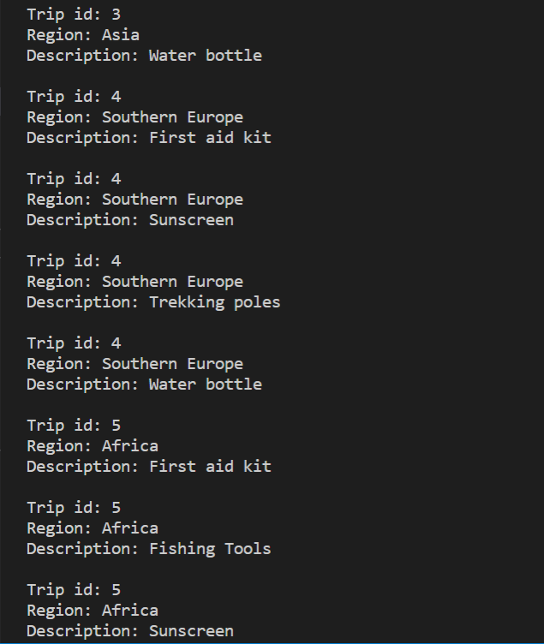

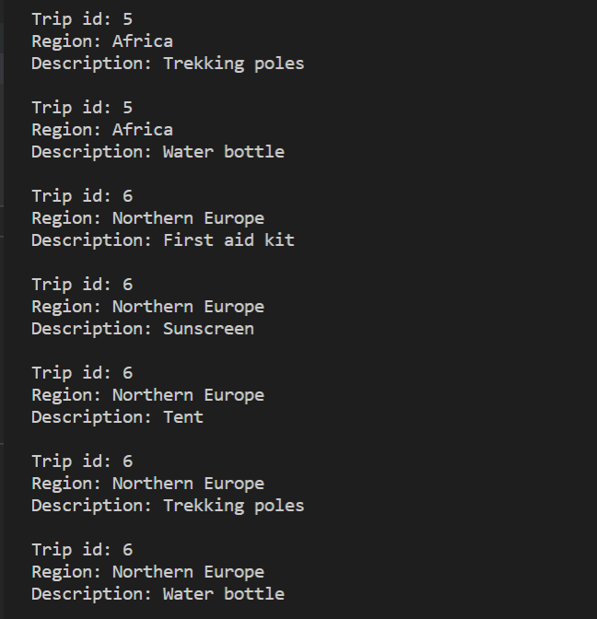

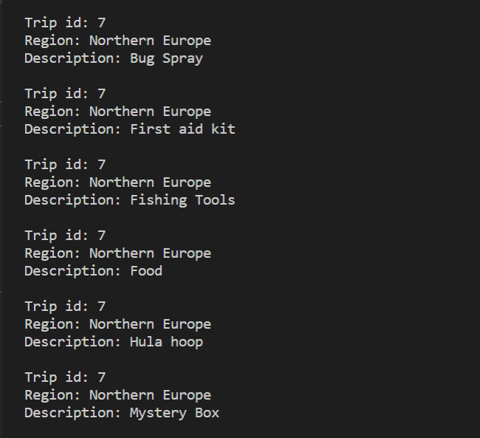

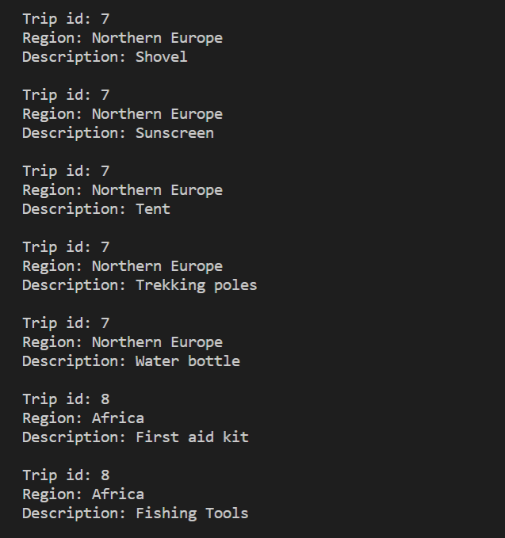

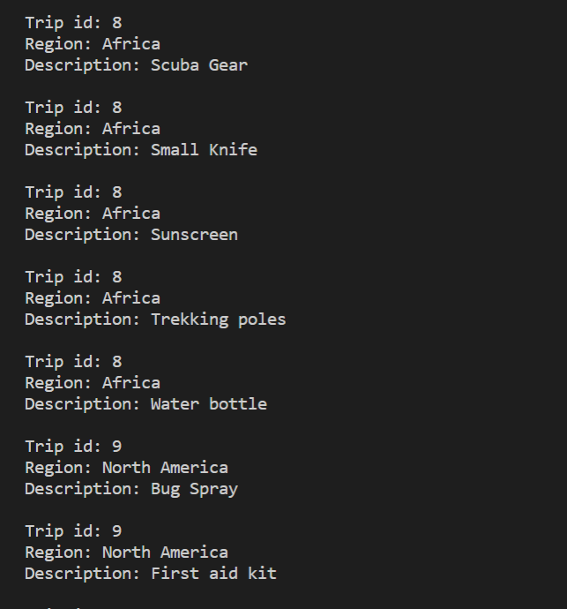

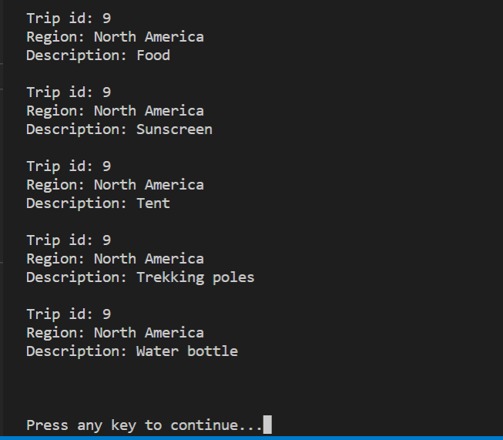

## 7.Customer Visa And Shot Records

## 8.Employee Visa And Shot Records

### Purpose of Reports

These reports provide inoculation and visa details for each customer or employee for the regions and dates they plan to travel.

-Administration and Guides need these reports to determine inoculation and visa compliance

### Report Description

Report 7. provides customer details for each scheduled trip. It gives the guides a quick view of which customer(s) have satisfied their inoculation and visa requirements. If “NULL” is in the “has_inoculcation_type” or “has_visa_in_country”, the guides will be able to quickly gather that information and notify the customer(s) of the requirements.

Report 8. provides employee details for each scheduled trip. It gives the Administration a quick view of which employee(s) have satisfied their inoculation and visa requirements. If “NULL” is in the “has_inoculcation_type” or “has_visa_in_country”, the Administration will be able to quickly gather that information and notify the appropriate employee(s) of the requirements.

#### 7.Customer Visa and Shot Records Report

Guide(s) & Customers going on which trips inoculation and visa requirements

-confirm visa

-confirm shots

SELECT abc.customer_trip_id, abc.trip_id, a.begin_date, a.end_date, b.first_name, b.last_name, c.region, e.inoculation_type AS required_inoculation_type, report_data.has_inoculation_type, report_data.date_expires, visa_report.required_country_visa, visa_report.has_visa_in_contry, visa_report.visa_number

FROM customer_trip AS abc

INNER JOIN trip AS a

ON abc.trip_id = a.trip_id

INNER JOIN customer AS b

ON abc.customer_id = b.customer_id

INNER JOIN destination AS c

ON a.destination_id = c.destination_id

INNER JOIN destination_inoculation AS d

ON c.destination_id = d.destination_id

INNER JOIN inoculation AS e

ON d.inoculation_id = e.inoculation_id

LEFT JOIN (

SELECT a.customer_trip_id, g.first_name, c.inoculation_type AS has_inoculation_type, b.date_expires, b.inoculation_id, b.customer_inoculation_id

FROM customer AS g

INNER JOIN customer_inoculation AS b

ON g.customer_id = b.customer_id

INNER JOIN customer_trip AS a

ON g.customer_id = a.customer_id

INNER JOIN inoculation AS c

ON b.inoculation_id = c.inoculation_id

) report_data ON abc.customer_trip_id = report_data.customer_trip_id AND e.inoculation_type = report_data.has_inoculation_type

INNER JOIN (

SELECT abc.customer_trip_id, abc.trip_id, a.begin_date, a.end_date, b.first_name, b.last_name, c.region, e.country As required_country_visa, report_data.has_visa_in_contry, report_data.visa_number

FROM customer_trip AS abc

INNER JOIN trip AS a

ON abc.trip_id = a.trip_id

INNER JOIN customer AS b

ON abc.customer_id = b.customer_id

INNER JOIN destination AS c

ON a.destination_id = c.destination_id

INNER JOIN destination_visa AS d

ON c.destination_id = d.destination_id

INNER JOIN visa AS E

ON d.visa_id = e.visa_id

LEFT JOIN (

SELECT a.customer_trip_id, g.first_name, c.country AS has_visa_in_contry, b.visa_number, b.visa_id

FROM customer AS g

INNER JOIN customer_visa AS b

ON g.customer_id = b.customer_id

INNER JOIN customer_trip AS a

ON g.customer_id = a.customer_id

INNER JOIN visa AS c

ON b.visa_id = c.visa_id

) report_data ON abc.customer_trip_id = report_data.customer_trip_id AND e.country = report_data.has_visa_in_contry

) visa_report ON abc.customer_trip_id = visa_report.customer_trip_id;

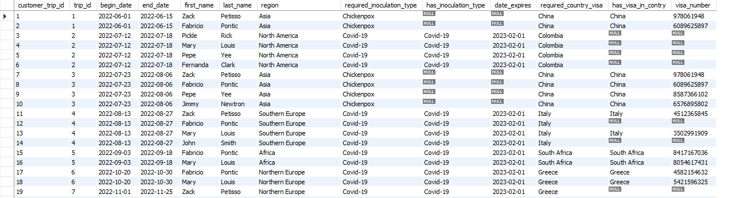

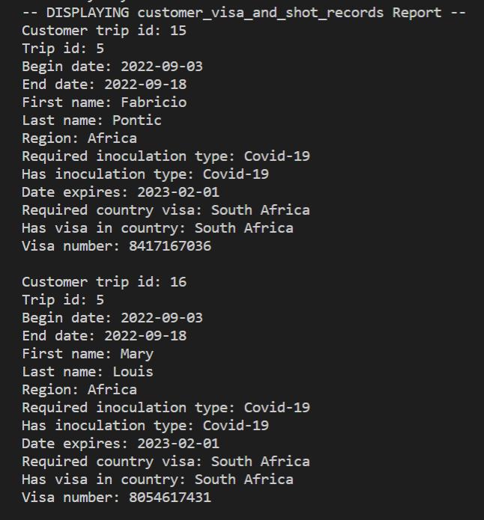

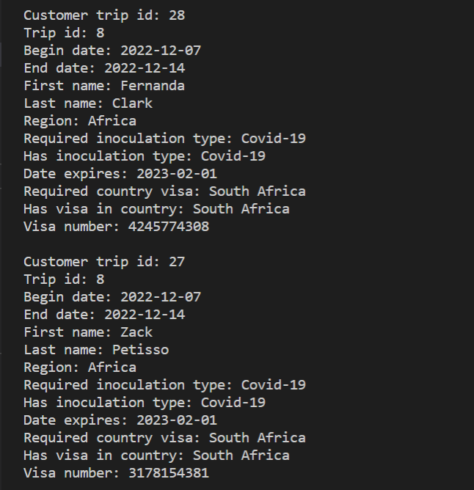

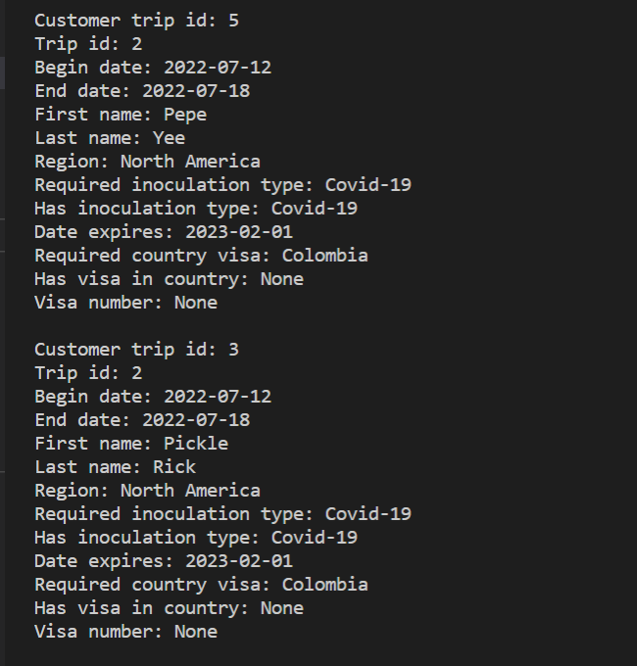

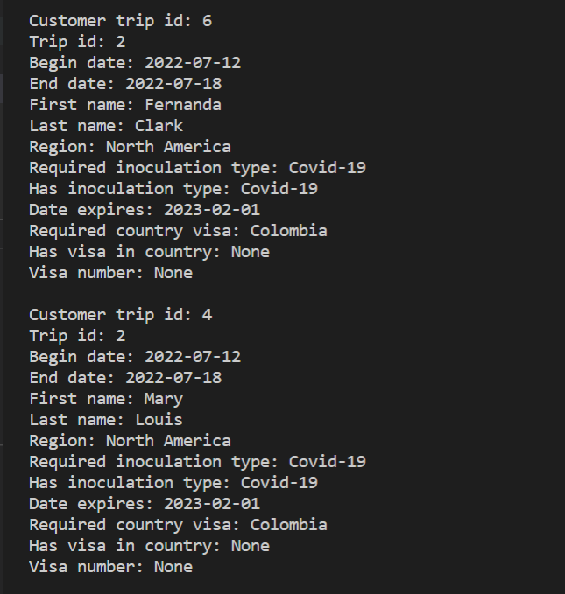

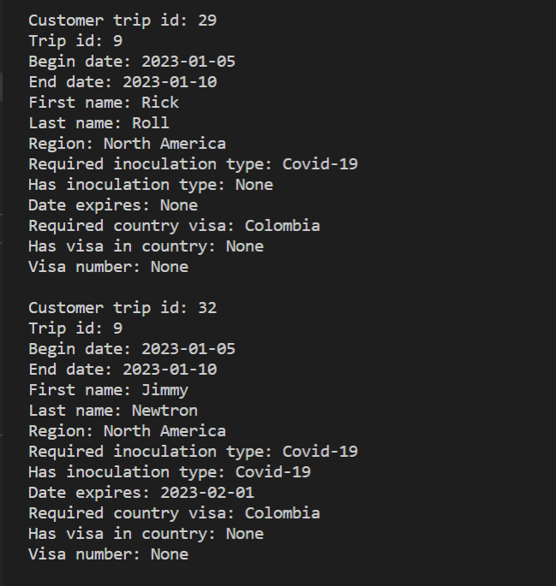

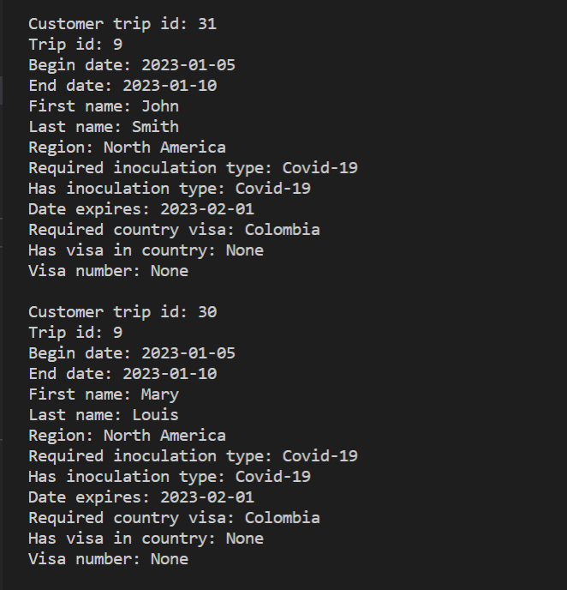

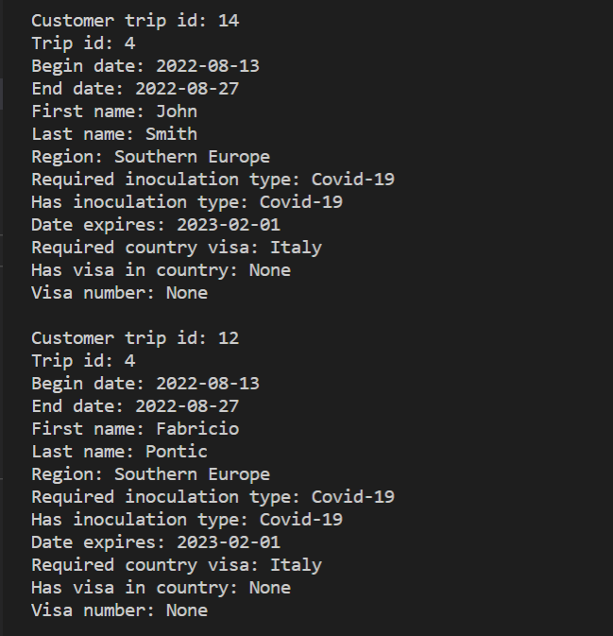

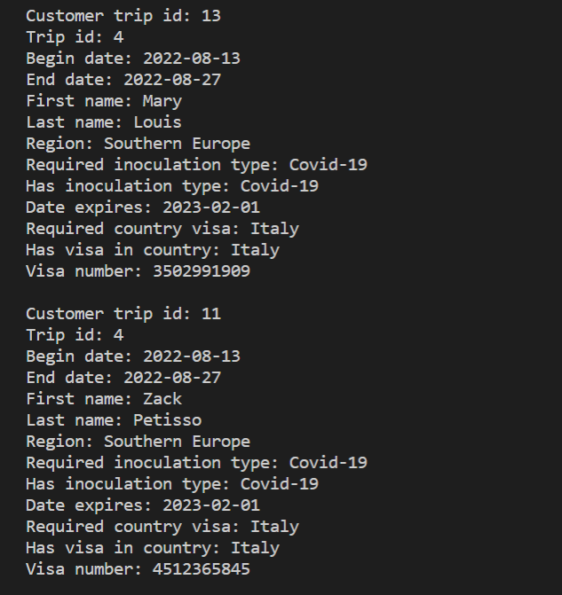

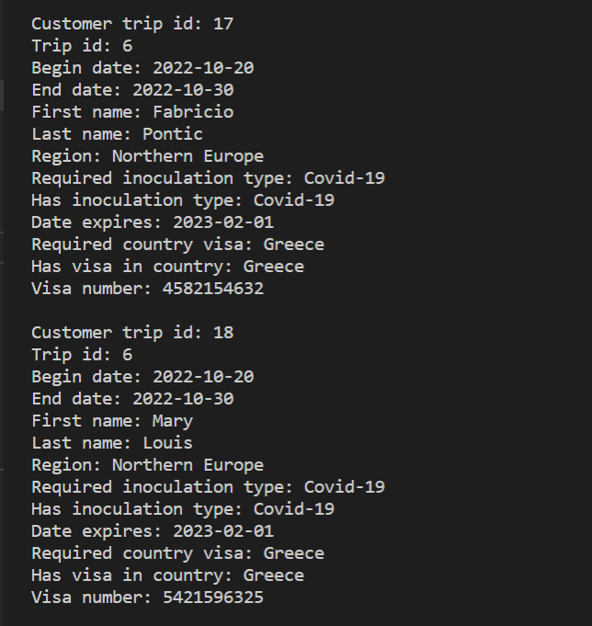

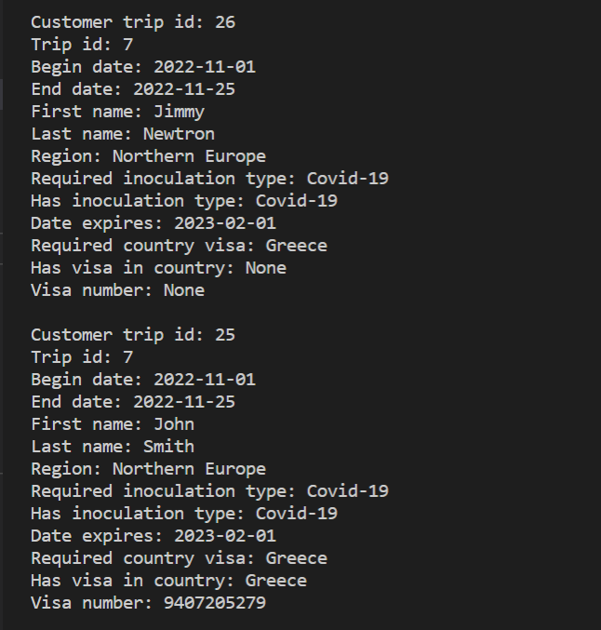

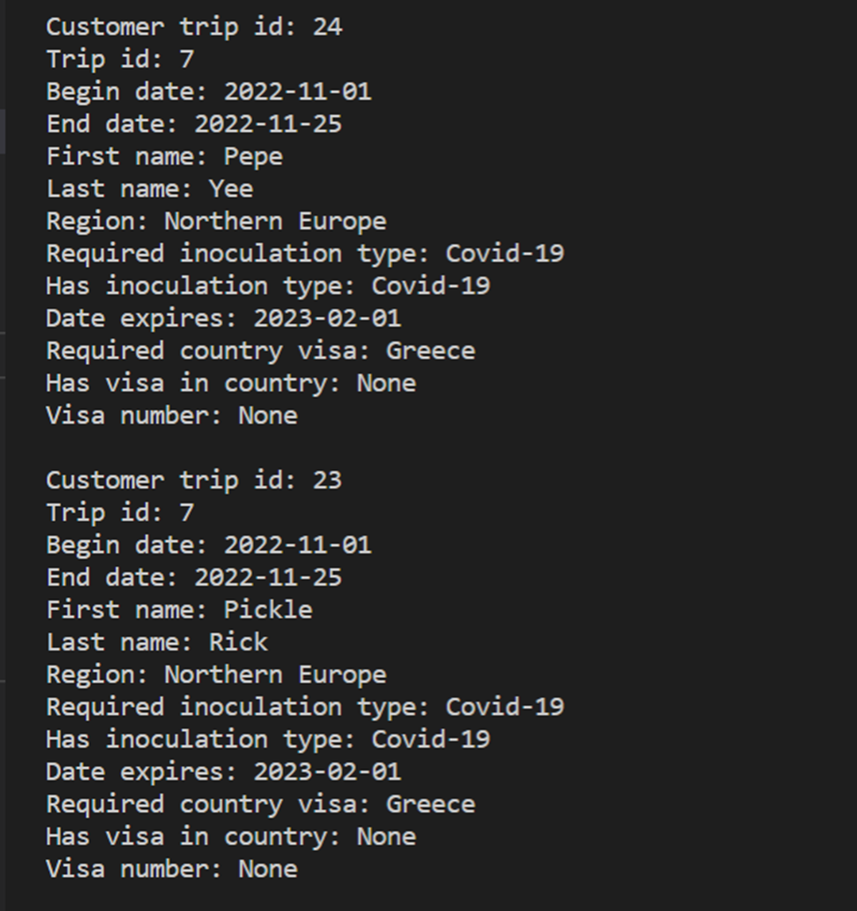

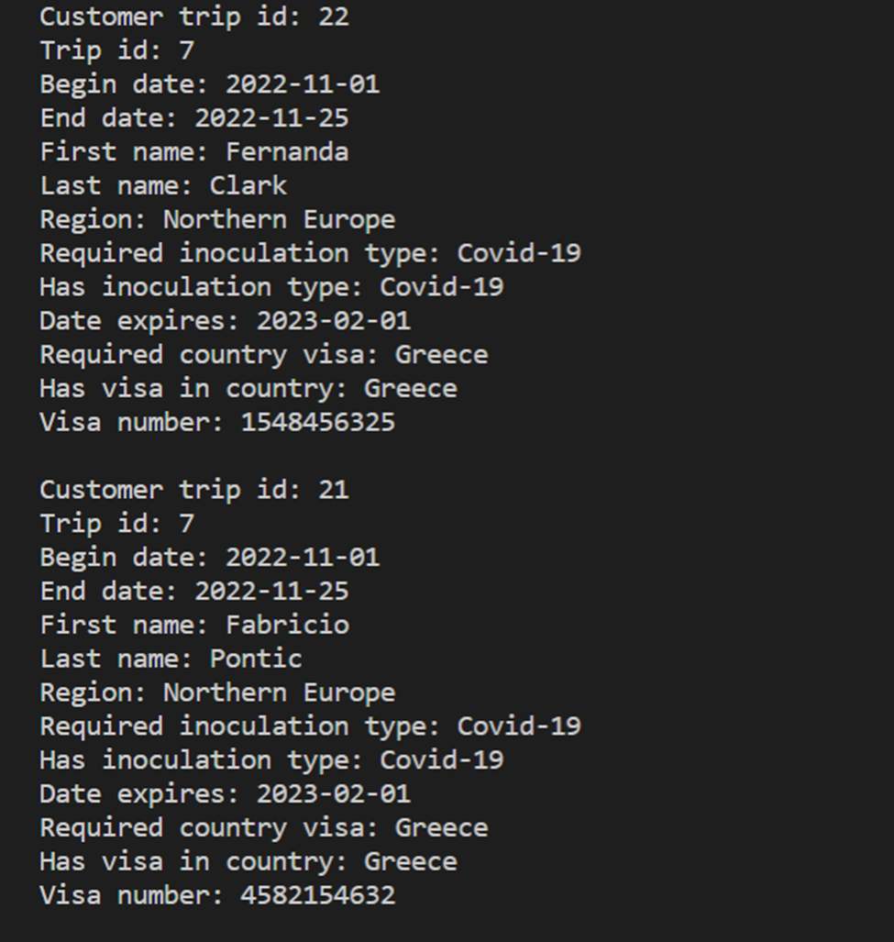

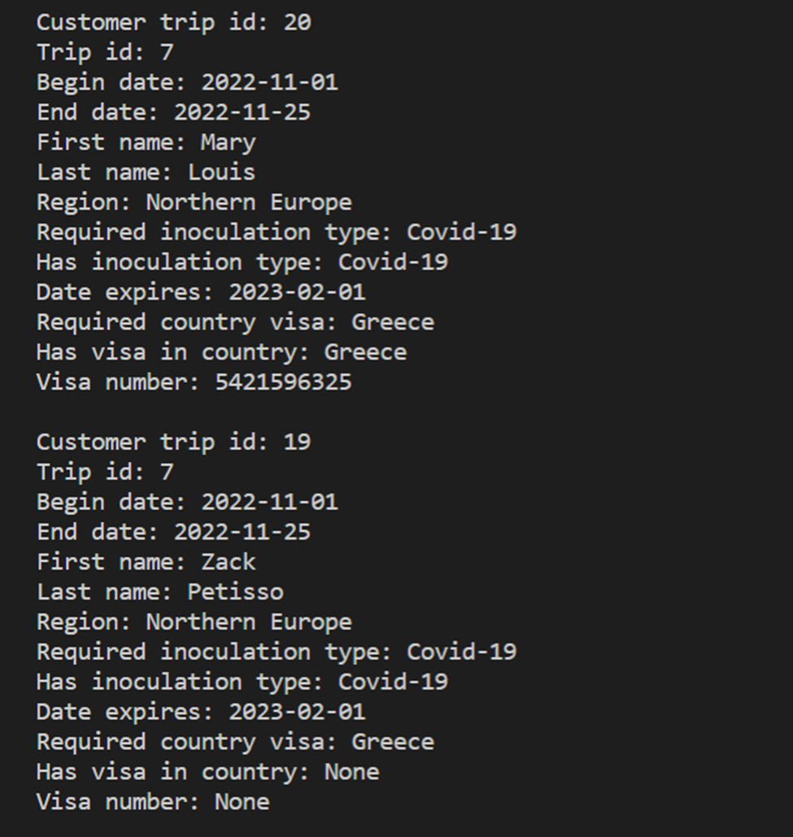

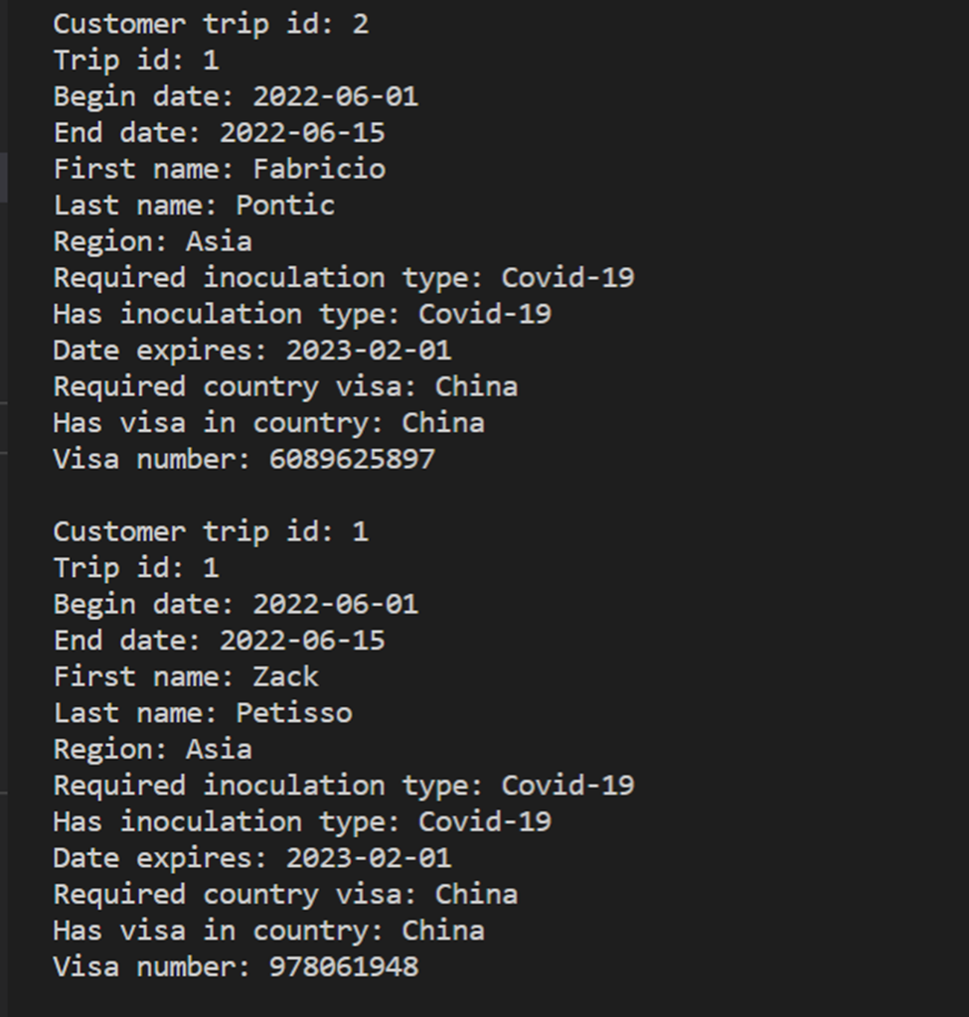

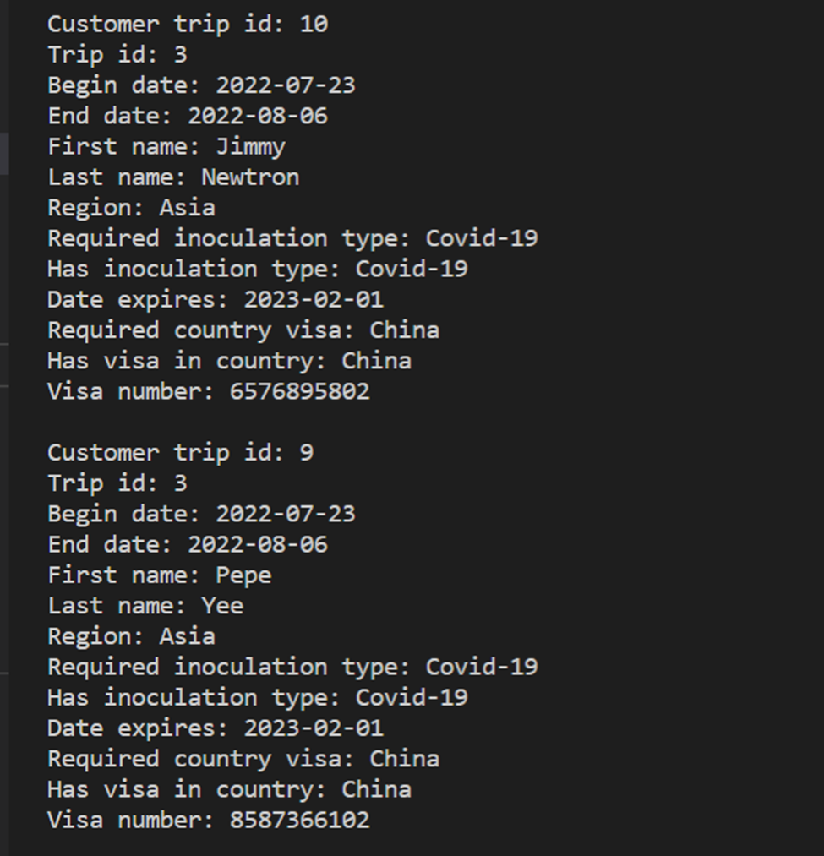

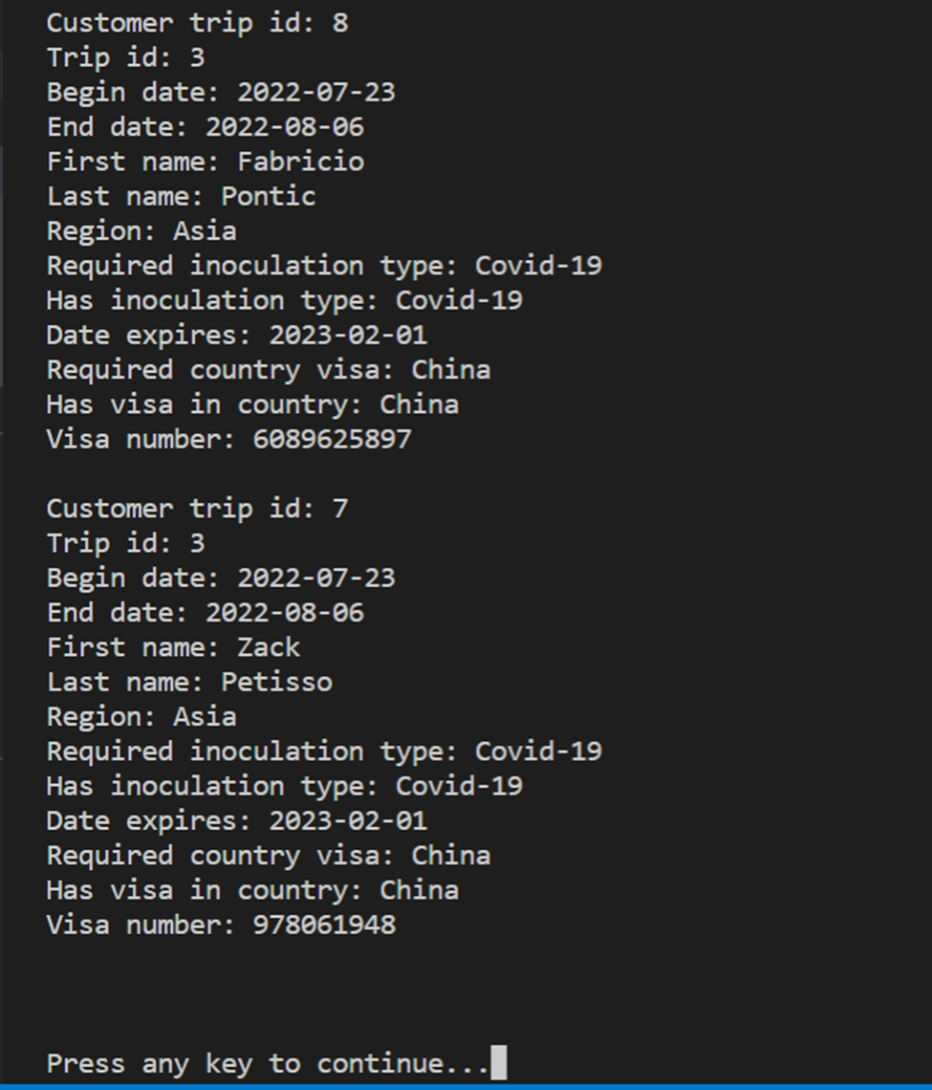

#### 8.Employee Visa And Shot Records Report

CREATE VIEW employee_visa_and_shot_records AS

SELECT abc.employee_trip_id, abc.trip_id, a.begin_date, a.end_date, b.first_name, b.last_name, c.region, e.inoculation_type AS required_inoculation_type, report_data.has_inoculation_type, report_data.date_expires, visa_report.required_country_visa, visa_report.has_visa_in_contry, visa_report.visa_number

FROM employee_trip AS abc

INNER JOIN trip AS a

ON abc.trip_id = a.trip_id

INNER JOIN employee AS b

ON abc.employee_id = b.employee_id

INNER JOIN destination AS c

ON a.destination_id = c.destination_id

INNER JOIN destination_inoculation AS d

ON c.destination_id = d.destination_id

INNER JOIN inoculation AS e

ON d.inoculation_id = e.inoculation_id

LEFT JOIN (

SELECT a.employee_trip_id, g.first_name, c.inoculation_type AS has_inoculation_type, b.date_expires, b.inoculation_id, b.employee_inoculation_id

FROM employee AS g

INNER JOIN employee_inoculation AS b

ON g.employee_id = b.employee_id

INNER JOIN employee_trip AS a

ON g.employee_id = a.employee_id

INNER JOIN inoculation AS c

ON b.inoculation_id = c.inoculation_id

) report_data ON abc.employee_trip_id = report_data.employee_trip_id AND e.inoculation_type = report_data.has_inoculation_type

INNER JOIN (

SELECT abc.employee_trip_id, abc.trip_id, a.begin_date, a.end_date, b.first_name, b.last_name, c.region, e.country As required_country_visa, report_data.has_visa_in_contry, report_data.visa_number

FROM employee_trip AS abc

INNER JOIN trip AS a

ON abc.trip_id = a.trip_id

INNER JOIN employee AS b

ON abc.employee_id = b.employee_id

INNER JOIN destination AS c

ON a.destination_id = c.destination_id

INNER JOIN destination_visa AS d

ON c.destination_id = d.destination_id

INNER JOIN visa AS E

ON d.visa_id = e.visa_id

LEFT JOIN (

SELECT a.employee_trip_id, g.first_name, c.country AS has_visa_in_contry, b.visa_number, b.visa_id

FROM employee AS g

INNER JOIN employee_visa AS b

ON g.employee_id = b.employee_id

INNER JOIN employee_trip AS a

ON g.employee_id = a.employee_id

INNER JOIN visa AS c

ON b.visa_id = c.visa_id

) report_data ON abc.employee_trip_id = report_data.employee_trip_id AND e.country = report_data.has_visa_in_contry

) visa_report ON abc.employee_trip_id = visa_report.employee_trip_id;

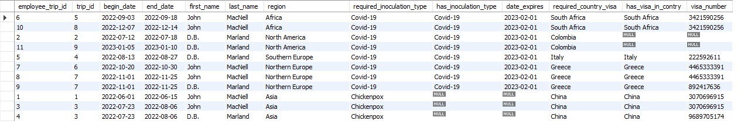

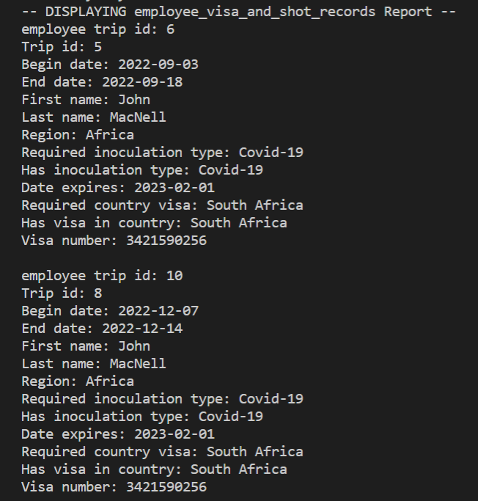

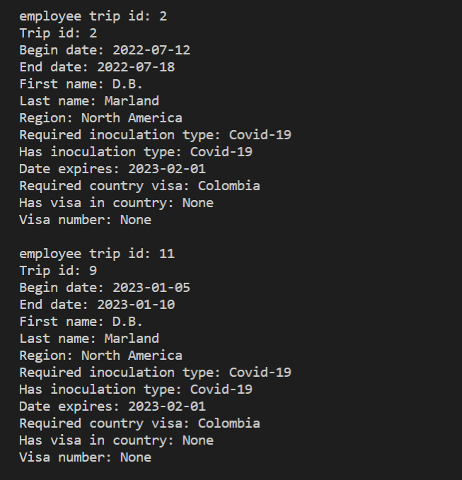

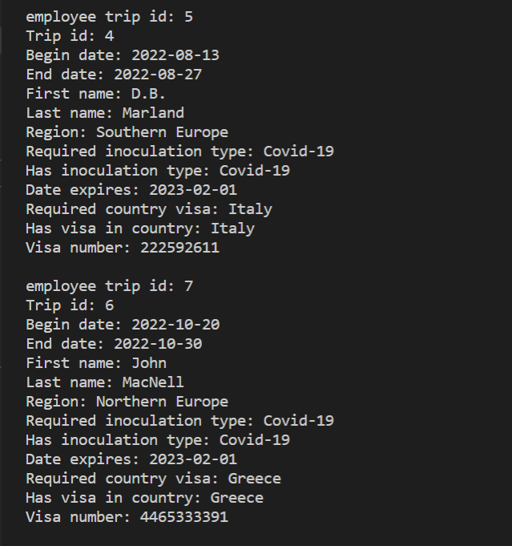

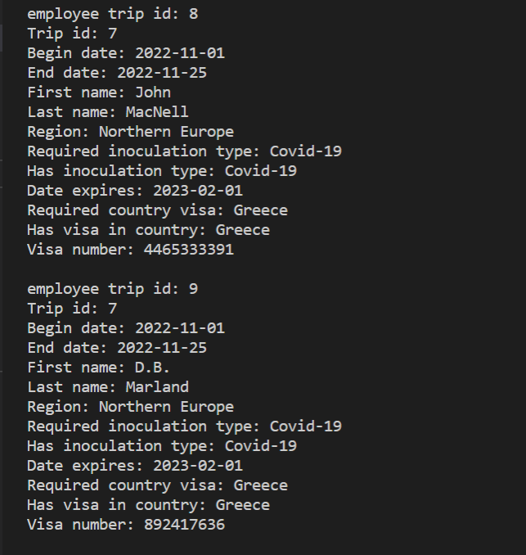

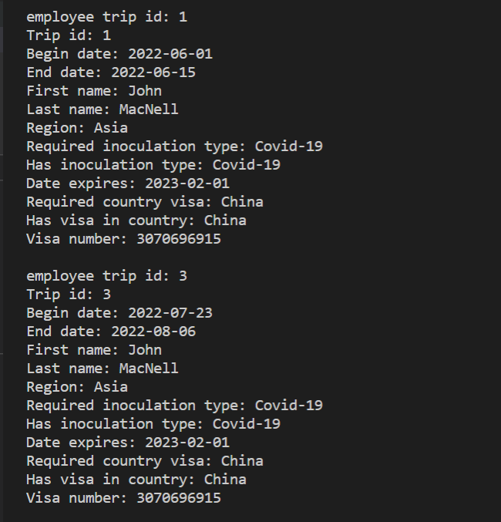

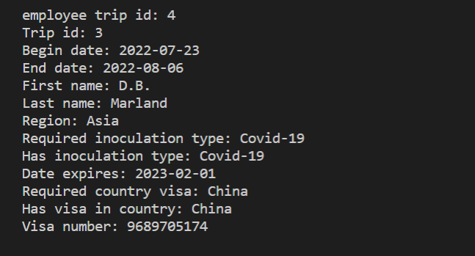

## 9.Trip Schedule Report

### Purpose of Report

-Mei Wong needs a report so potential customers can check on trip schedules

### Report Description

This report displays the beginning and ending dates for each trip along with each excursion and its date that is a part of that trip. Each trip is listed for as many times as the amount of excursions on that trip. The trip_id and region name are displayed for each trip. Each excursion has the event description and the date it takes place on. A “WHERE T.trip_id = ?” clause could be run on the view to limit the results to one trip, which would make the result useful as a trip itinerary.

#### 9.Trip Schedule Report

SELECT T.trip_id, D.region,

DATE_FORMAT(T.begin_date,'%m/%d/%Y') AS 'Begin Date',

DATE_FORMAT(T.end_date,'%m/%d/%Y') AS 'End Date',

DATE_FORMAT(TE.date,'%m/%d/%Y') AS 'Excursion Date',

E.excursion_description

FROM trip AS T

JOIN destination AS D

ON T.destination_id = D.destination_id

JOIN trip_excursion AS TE

ON TE.trip_id = T.trip_id

JOIN excursion AS E

ON E.excursion_id = TE.excursion_id

ORDER BY T.begin_date, TE.date;

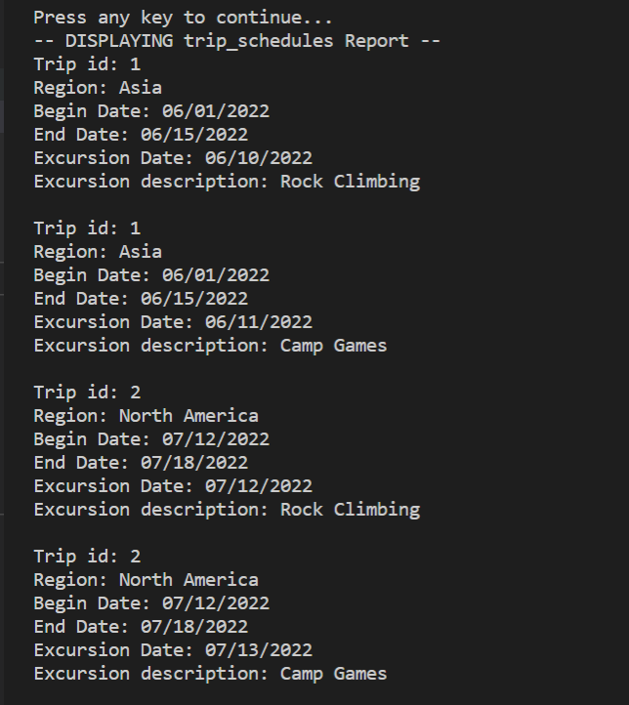

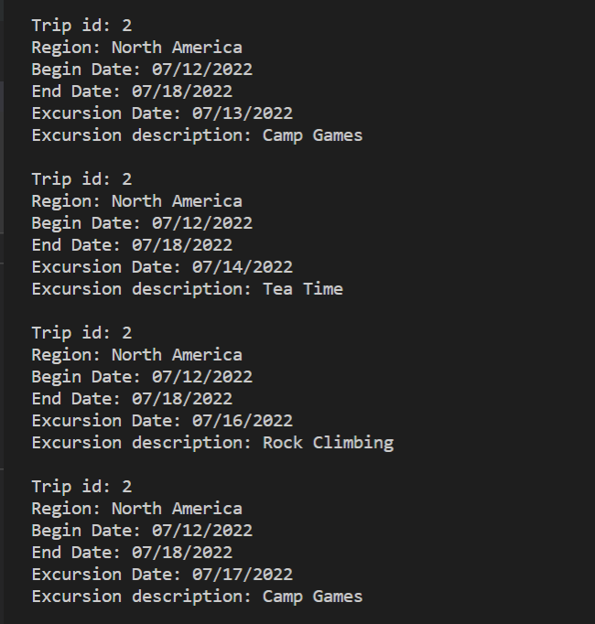

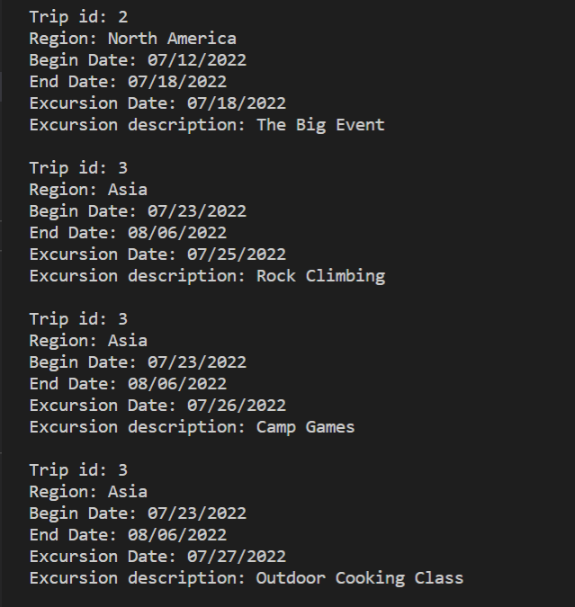

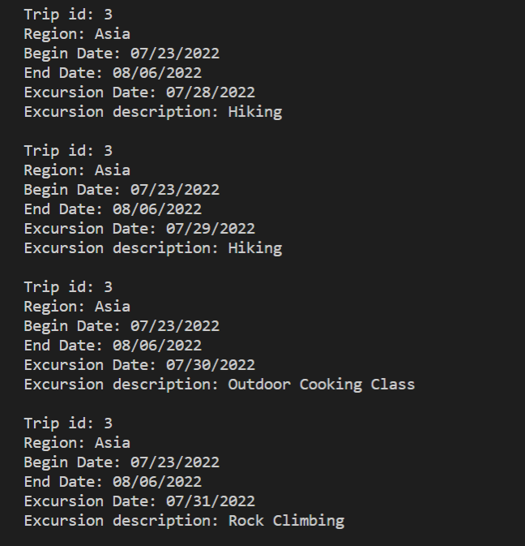

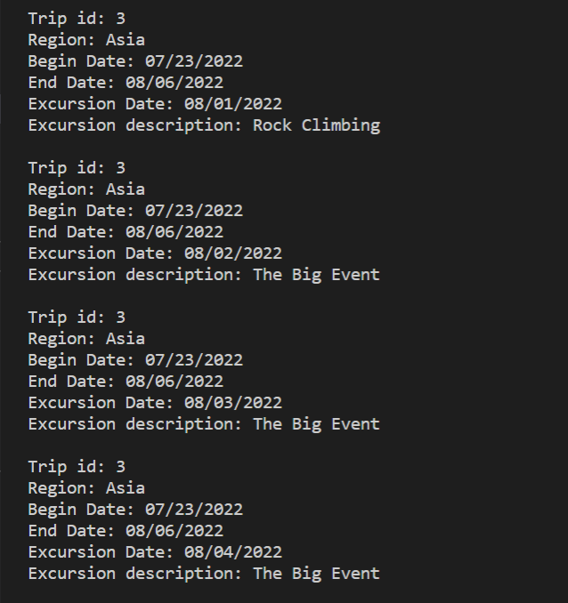

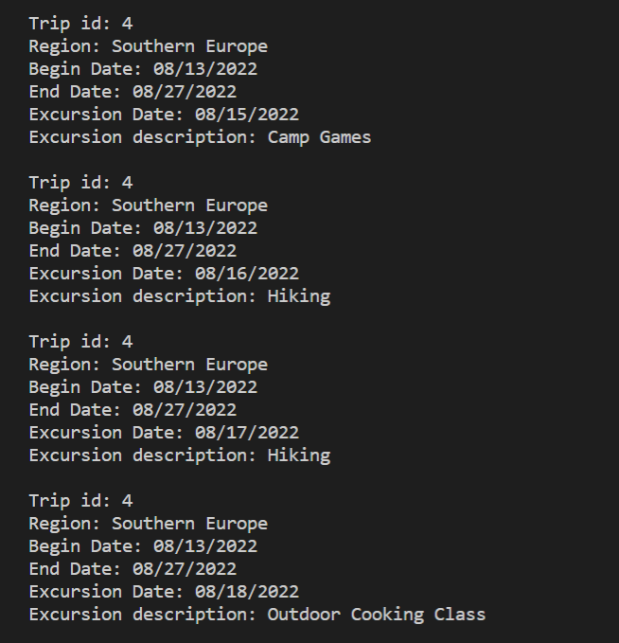

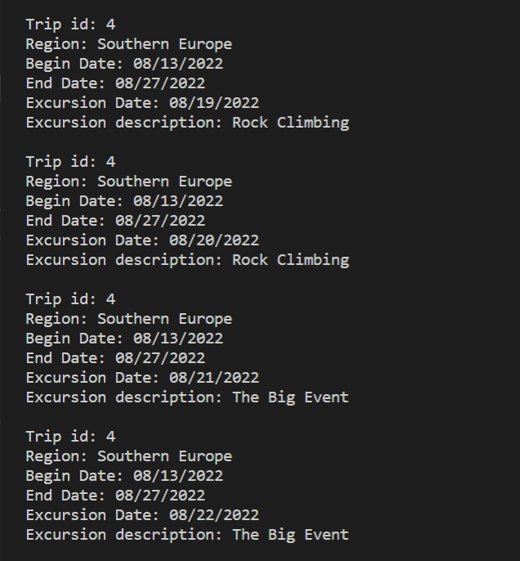

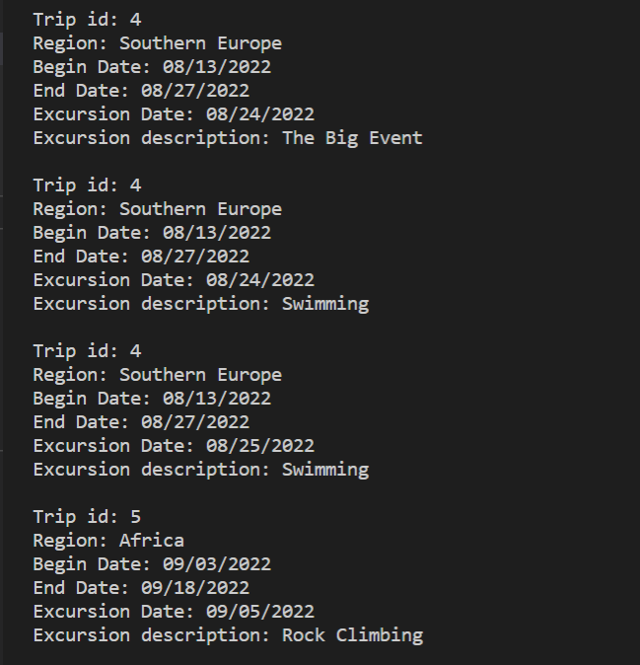

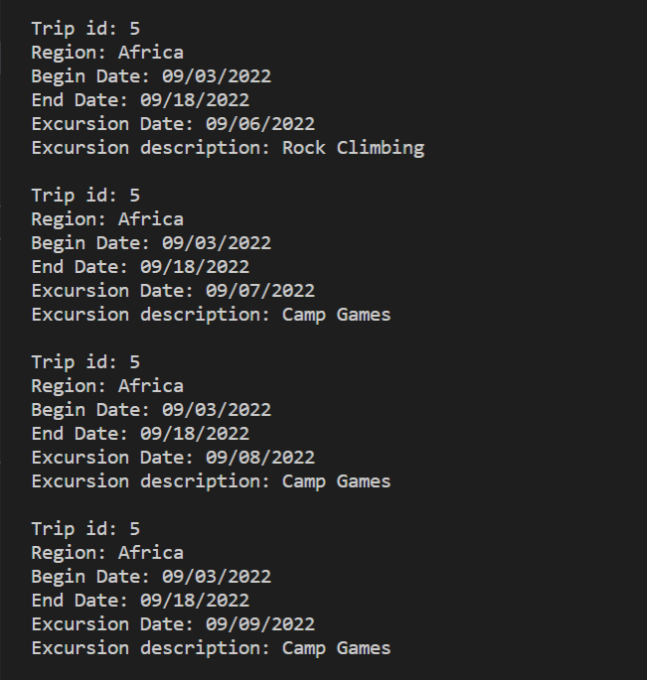

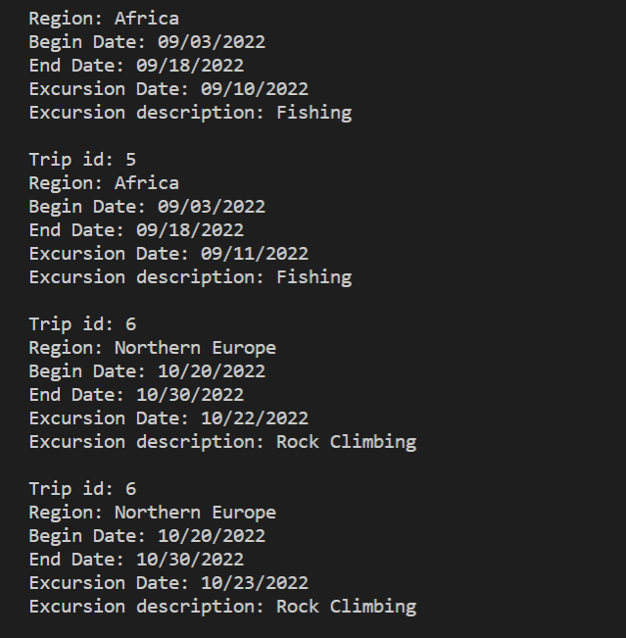

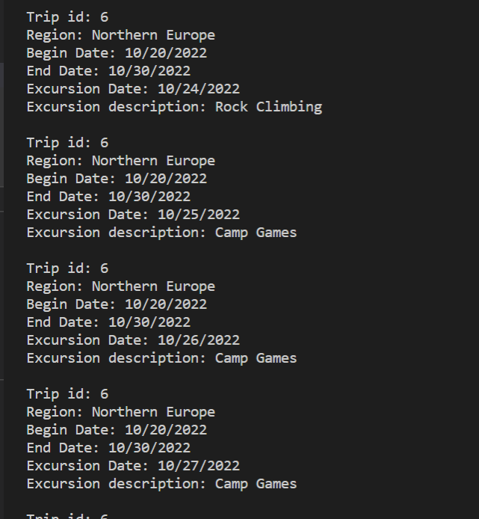

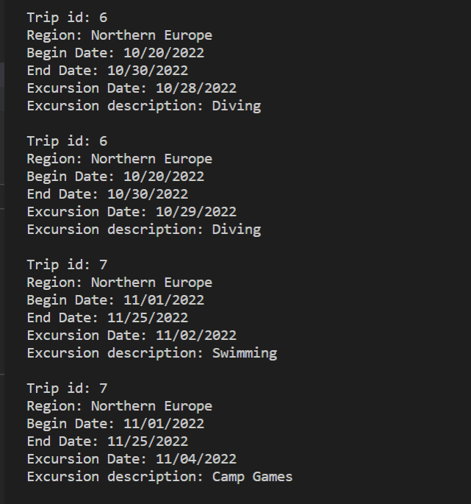

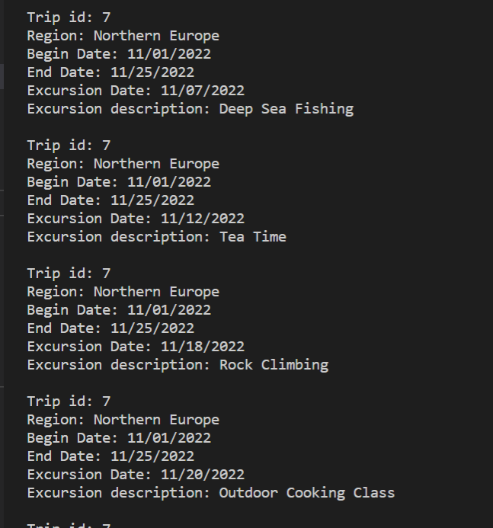

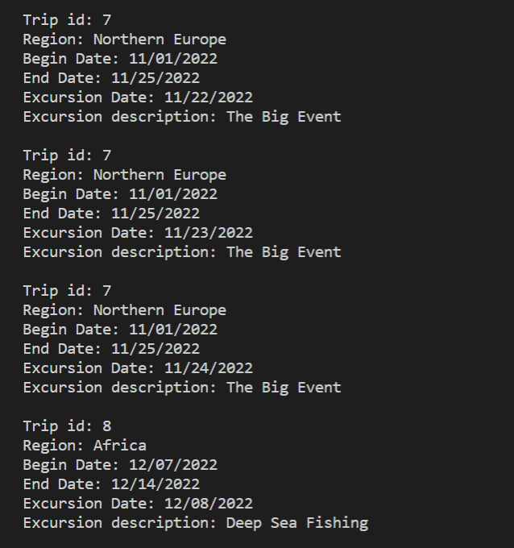

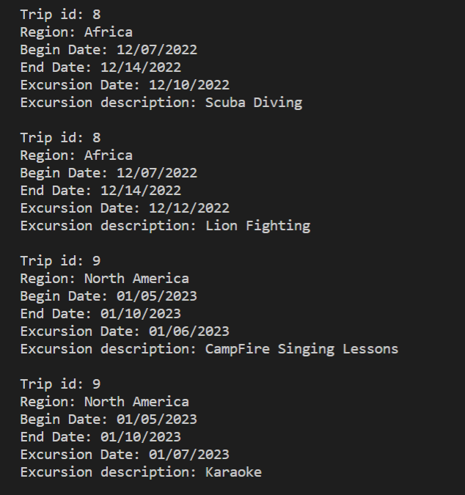

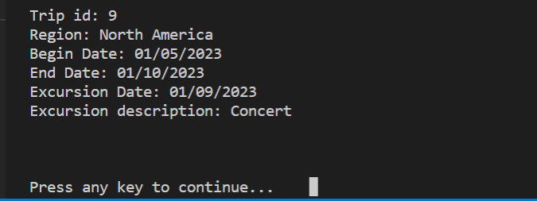

## 10-A.Item By Age Report

## 10-B.Item By Age Report

### Purpose of Reports

These reports provide inventory details.

The interactive report is used to identify the equipment with an age greater than the age entered.

-Dimitrios needs reports for equipment inventory and maintenance.

#### 10-A.Item By Age Report

--all items

SELECT I.item_id, IT.description,

DATEDIFF(CURDATE(), I.date_aquired) AS 'Age in Days',

DATEDIFF(CURDATE(), I.date_aquired)/365.25 AS 'Age in Years',

DATE_FORMAT(I.date_aquired,'%m/%d/%Y') AS 'Date Acquired'

FROM item AS I

JOIN item_type AS IT

ON i.item_type_id = IT.item_type_id

ORDER BY I.date_aquired;

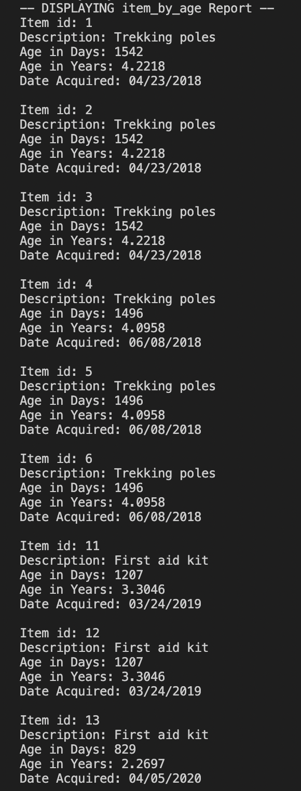

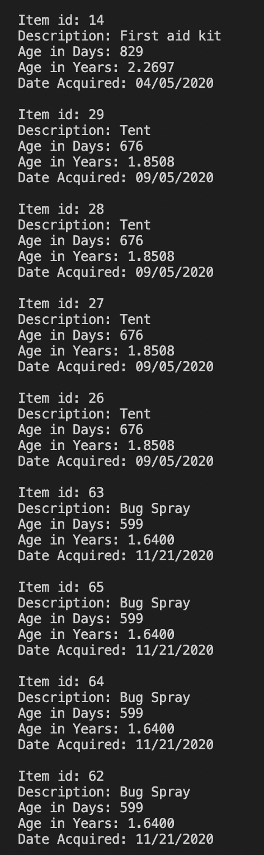

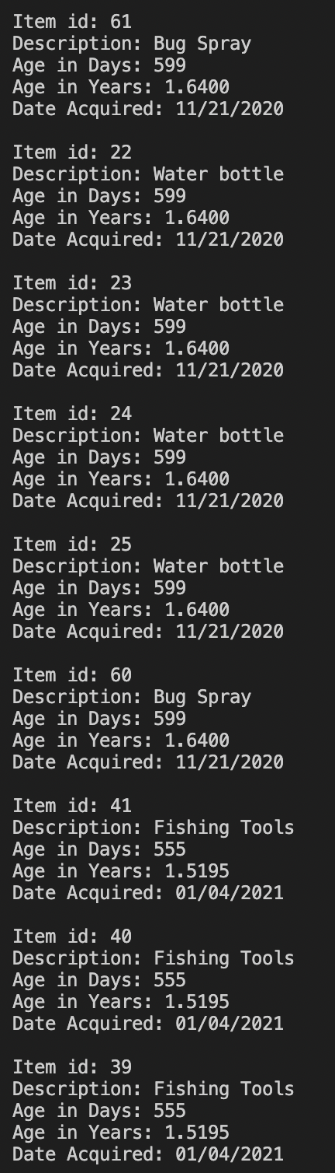

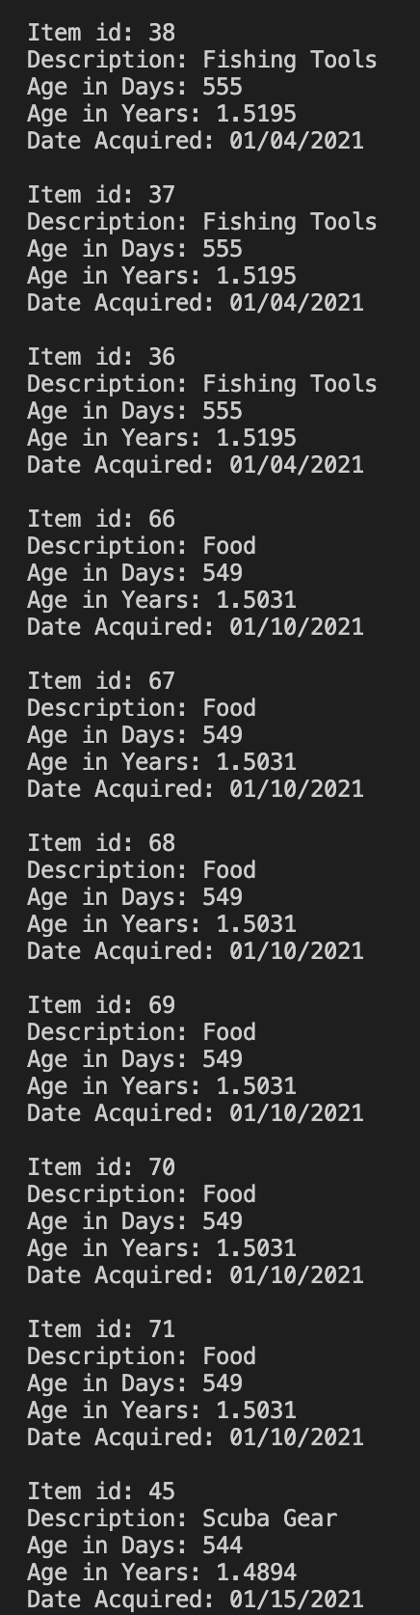

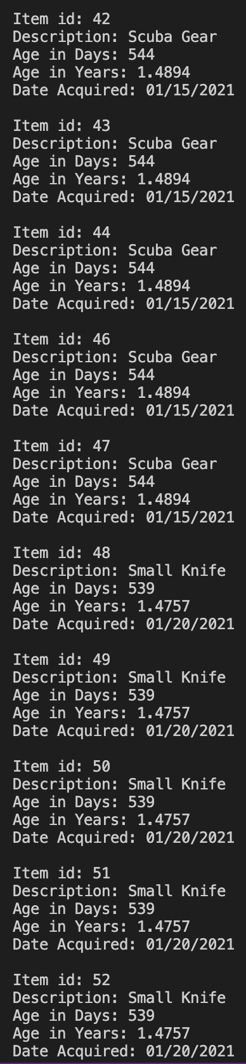

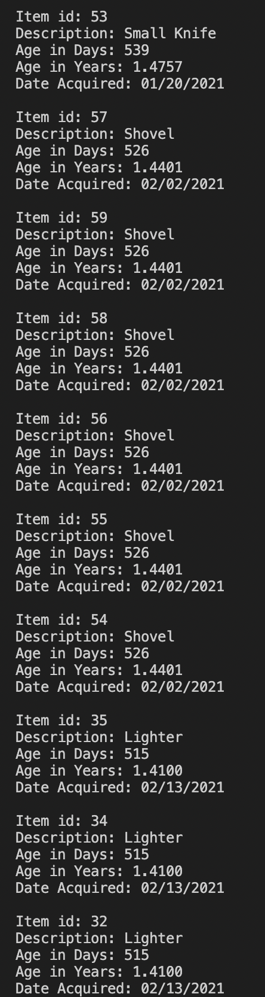

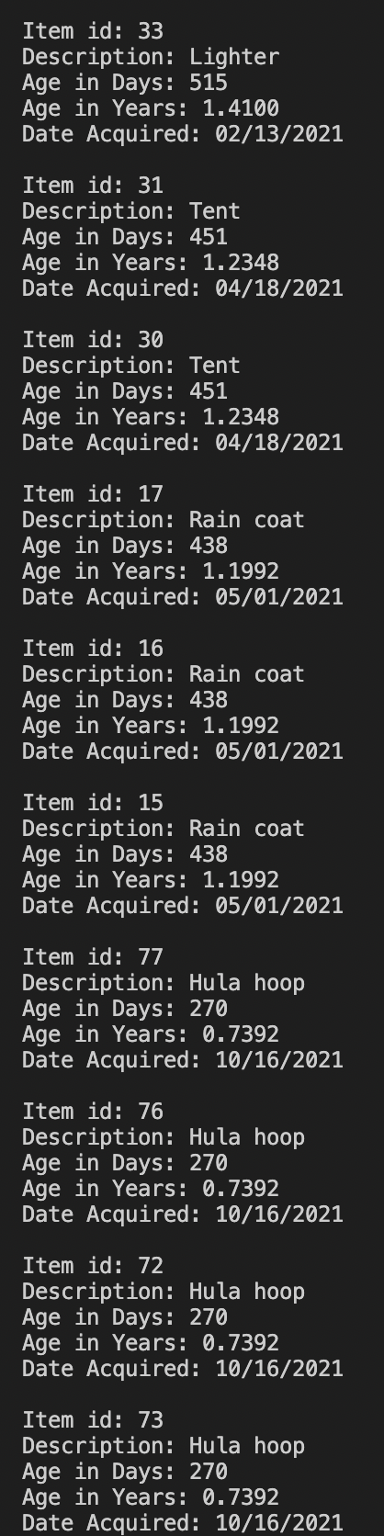

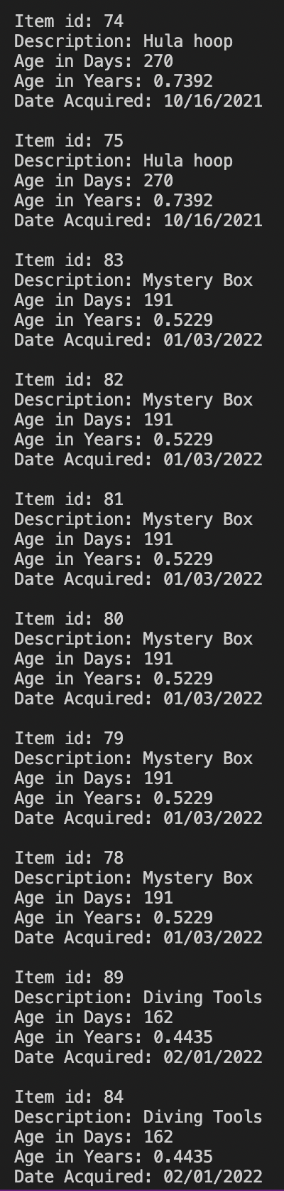

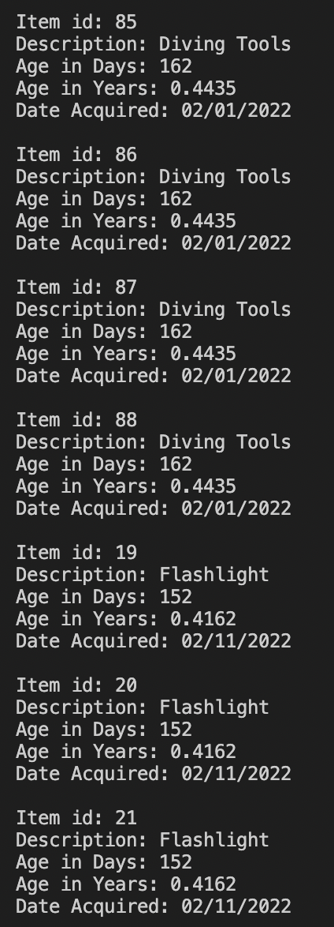

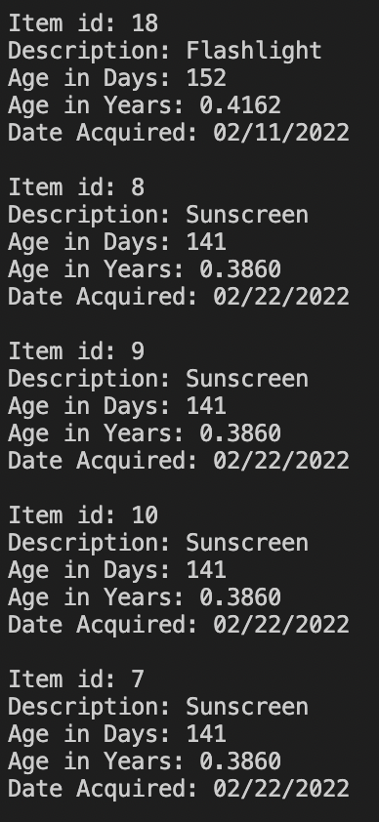

### Report Description

This report can either be a fixed view or a procedure. These reports build on the last one by limiting the returned records to only the items with an age greater than or equal to the specified age. The age value can be hard coded into a select statement or view, or the procedure can be called with an int value to be used as the age in the command. Dimitrios needed a report to view items that were greater than 5 years old. While you could hard code 5 as the age or input 5 into the procedure and it would return the correct records, our data assumed most items were purchased new in recent years and no items are over 5 years old. If you run either report with a lower value such as an age of 3 or 4, it will return matching records.

#### 10-B.Item By Age Report Interactive

--items over X years old

SELECT I.item_id, IT.description,

DATEDIFF(CURDATE(), I.date_aquired) AS 'Age in Days',

DATEDIFF(CURDATE(), I.date_aquired)/365.25 AS 'Age in Years',

DATE_FORMAT(I.date_aquired,'%m/%d/%Y') AS 'Date Acquired'

FROM item AS I

JOIN item_type AS IT

ON i.item_type_id = IT.item_type_id

WHERE (DATEDIFF(CURDATE(), I.date_aquired)/365.25) >= 4

ORDER BY I.date_aquired;

--create procedure

CREATE PROCEDURE OldItems (IN age int)

BEGIN

SELECT I.item_id, IT.description,

DATEDIFF(CURDATE(), I.date_aquired) AS 'Age in Days',

DATEDIFF(CURDATE(), I.date_aquired)/365.25 AS 'Age in Years',

DATE_FORMAT(I.date_aquired,'%m/%d/%Y') AS 'Date Acquired'

FROM item AS I

JOIN item_type AS IT

ON i.item_type_id = IT.item_type_id

WHERE (DATEDIFF(CURDATE(), I.date_aquired)/365.25) >= age

ORDER BY I.date_aquired;

END

CALL OldItems(4)

